**INSIGHTSTREAM:NAVIGATE THE NEWS LANDSCAPE**

REACT.JS

**PROJECT REPORT**

**SUBMITTED TO THE NAAN MUDHALVAN IN THE PARTIAL**

**FULFILLMENT OF THE REQUIREMENT FOR THE**

**DEGREE OF BACHELOR OF COMPUTER SCIENCE**

**BY**

**TEAM LEADER: LOHITH S**

**TEAM MEMBER 1: ASWIN S**

**TEAM MEMBER 2: BALA M**

**TEAM MEMBER 3: KISHOR KUMAR B**



**DEPARTMENT OF COMPUTER APPLICATION**

**PROF.DHANAPALAN COLLEGE SCIENCE AND MANAGEMENT**

**KELAMBAKKAM**

**MARCH-2025**

**INTRODUCTION**

The rapid evolution of technology has led to significant changes in the way news is consumed, especially with the rise of digital platforms. In the digital age, traditional media, such as print newspapers, radio, and television, faces competition from online news sources, social media, and aggregation platforms. Despite this shift, traditional media still plays a crucial role in the contemporary media landscape. This paper explores the interplay between traditional media and digital news consumption, analyzing their respective roles in shaping public opinion, the credibility of information, and the accessibility of news.

**PROJECT OVERVIEW**

While digital media offers immediacy and interactivity, it often lacks the editorial rigor and fact-checking standards associated with traditional outlets. In contrast, traditional media maintains established journalistic standards but is challenged by declining audiences and the shift towards online platforms. The paper examines how traditional media organizations are adapting to the digital environment by incorporating digital tools, creating online platforms, and using social media to engage audiences. Furthermore, the role of traditional media in providing in-depth, investigative reporting and local news is highlighted, emphasizing its continued importance in a landscape dominated by quick, often superficial digital content.

**ARCHITECTURE**

The paper concludes by arguing that the future of news consumption lies in a hybrid model that combines the strengths of both traditional and digital media. Traditional media must adapt to technological changes, while digital platforms must address concerns about misinformation and sensationalism. By exploring the balance between traditional and digital media, this paper contributes to the understanding of news consumption trends and their implications for society.

**USER INTERFACE**

The landscape of news consumption has undergone a profound transformation with the rise of digital media, leading to a dramatic shift in how people access and engage with news.

**SETUP INSTRUCTIONS**

traditional media outlets such as newspapers, television, and radio were the primary sources of news for most individuals. These platforms provided a structured, regulated approach to news delivery, often adhering to editorial standards and journalistic ethics. However, the digital revolution, marked by the rise of the internet and mobile technologies, has redefined how news is consumed, leading to the proliferation of online platforms, social media, and news aggregators that provide instant, personalized content.

**FOLDER STRUCTURE**

This evolution in news consumption has sparked a debate about the continued relevance of traditional media in the digital age. On one hand, digital platforms offer unprecedented access to information, allowing users to consume news at any time and from virtually anywhere. The ease of sharing content, real-time updates, and the interactive nature of digital media have reshaped how people engage with news. However, the rapid spread of misinformation, sensationalism, and the erosion of editorial standards in the digital sphere have raised concerns about the quality and reliability of news consumed online.

**RUNNING THE APPLICATION**

Despite the dominance of digital media, traditional media still holds a vital place in the contemporary media landscape. Established outlets, with their editorial teams, fact-checking processes, and long-standing reputations for credibility, continue to provide valuable, in-depth reporting that is often missing from digital platforms. Furthermore, traditional media remains a trusted source for investigative journalism, local news, and critical issues that require thorough, unbiased reporting. As news consumption patterns evolve, the intersection between traditional and digital media is becoming increasingly significant.

**COMPONENT DOCUMENTATION**

While digital platforms continue to grow in popularity, traditional media outlets are embracing technological advancements by expanding their online presence and adapting to new consumption habits. This hybrid approach, blending the strengths of both media forms, offers a promising model for the future of news consumption, credibility depth.

**STATE MANAGEMENT**

explore the evolving role of traditional media in the digital age, analyzing how it continues to shape news consumption and engage audiences. The focus will be on understanding the challenges faced by traditional media, the opportunities for innovation, and the ways in which both traditional and digital platforms can complement each other in shaping the future of news dissemination.

**The Hybrid Model: Combining the Strengths of Traditional and Digital Media**

In the evolving media landscape, a hybrid model is emerging where traditional and digital media work together to complement each other’s strengths. This integration allows for a more comprehensive approach to news consumption, combining the immediacy and interactivity of digital platforms with the credibility and depth of traditional media. As both media forms adapt to the changing demands of audiences, this convergence has the potential to enhance the overall news experience. One of the primary advantages of this hybrid model is the ability to reach a broader audience.

**STYLING**

Traditional media outlets, such as television stations, newspapers, and radio, have long established brands and a loyal audience base. By embracing digital platforms, these outlets can extend their reach, engaging younger audiences who primarily consume news online. Many traditional media organizations now have a strong online presence through websites, social media accounts, and mobile apps, enabling them to deliver news on-demand and in real-time. This approach ensures that they remain competitive in a landscape dominated by digital content.

**TESTING**

Digital platforms, on the other hand, benefit from the credibility and authority that traditional media brings. Social media and news aggregation sites often struggle with misinformation and sensationalism, as their algorithms prioritize speed over accuracy. By partnering with or referencing established traditional media outlets, digital platforms can enhance the reliability of the content they distribute fact.

**SOURCE CODE:**

**<!DOCTYPE html>**

**<html lang="en">**

**<head>**

**<meta charset="utf-8" />**

**<link rel="icon" href="%PUBLIC_URL%/favicon.ico" />**

**<meta name="viewport" content="width=device-width, initial-scale=1" />**

**<meta name="theme-color" content="#000000" />**

**<meta**

**name="description"**

**content="Web site created using create-react-app"**

**/>**

**<link rel="apple-touch-icon" href="%PUBLIC_URL%/logo192.png" />**

**<link rel="manifest" href="%PUBLIC_URL%/manifest.json" />**

**<title>S2P APP</title>**

**</head>**

**<body>**

**<noscript>You need to enable JavaScript to run this app.</noscript>**

**<div id="root"></div>**

**</body>**

**</html>**

**/bootstrap.min.css';**

**@import url('https://fonts.googleapis.com/css2?family=Poppins:wght@200;300;400;500;600;700;800;900&family=Whisper&display=swap');**

**body {**

**margin: 0;**

**font-family: 'Poppins', sans-serif;**

**-webkit-font-smoothing: antialiased;**

**-moz-osx-font-smoothing: grayscale;**

**-ms-overflow-style: none; /* IE and Edge */**

**scrollbar-width: none;**

**}**

**body::-webkit-scrollbar {**

**display: none;**

**}**

**code {**

**font-family: source-code-pro, Menlo, Monaco, Consolas, 'Courier New',**

**monospace;**

**}**

**.spinners{**

**display: flex;**

**justify-content: center;**

**align-items: center;**

**gap: 10px;**

**}**

**import React from 'react';**

**import ReactDOM from 'react-dom/client';**

**import './index.css';**

**import App from './App';**

**import reportWebVitals from './reportWebVitals';**

**import { BrowserRouter } from 'react-router-dom';**

**import GeneralContextProvider from './context/GeneralContext';**

**const root = ReactDOM.createRoot(document.getElementById('root'));**

**root.render(**

**<BrowserRouter>**

**<GeneralContextProvider>**

**<App />**

**</GeneralContextProvider>**

**</BrowserRouter>**

**reportWebVitals();**

**SCREENSHORT OR DEMO**

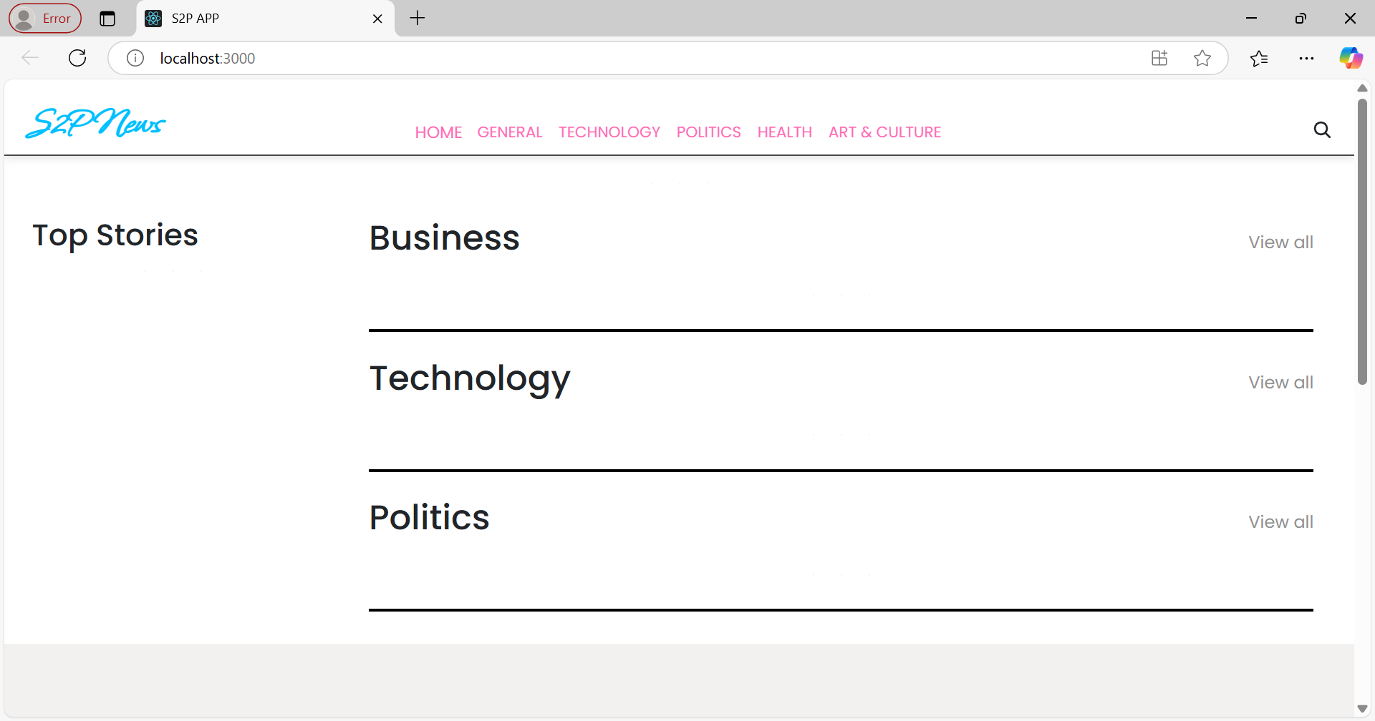

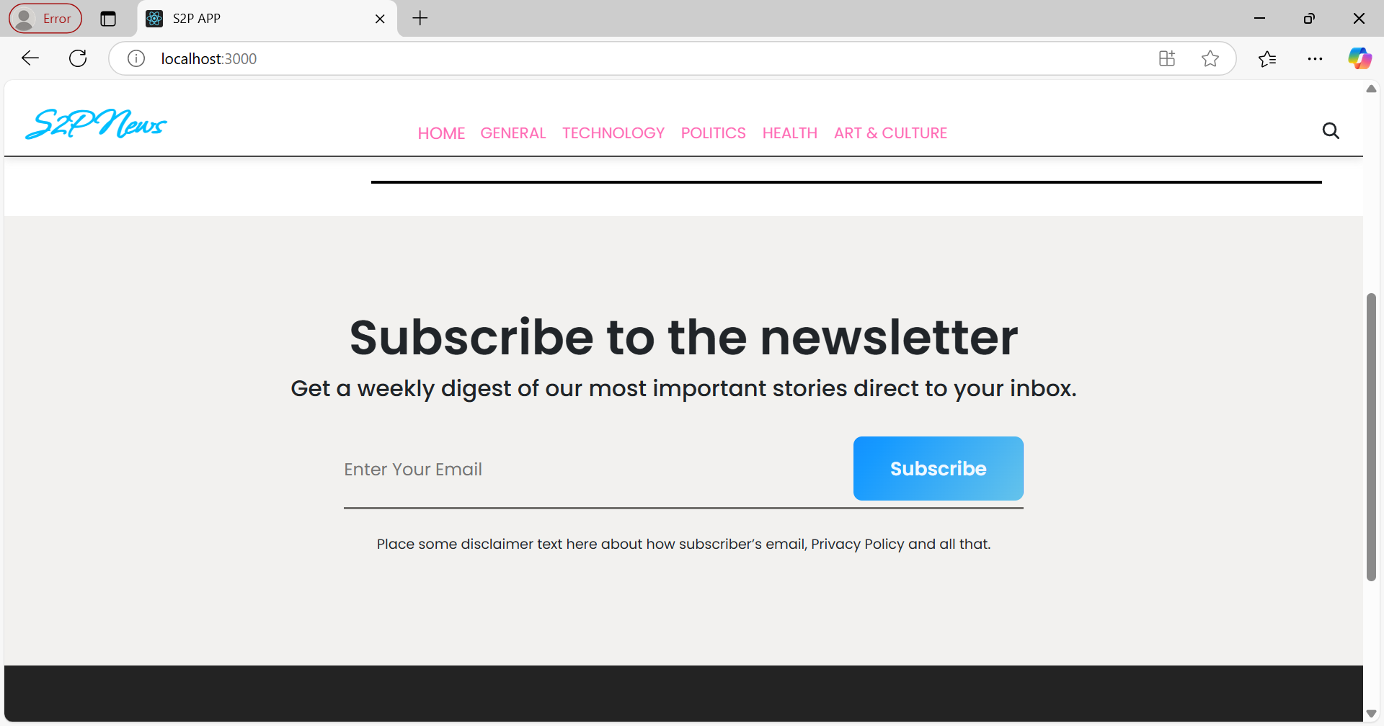

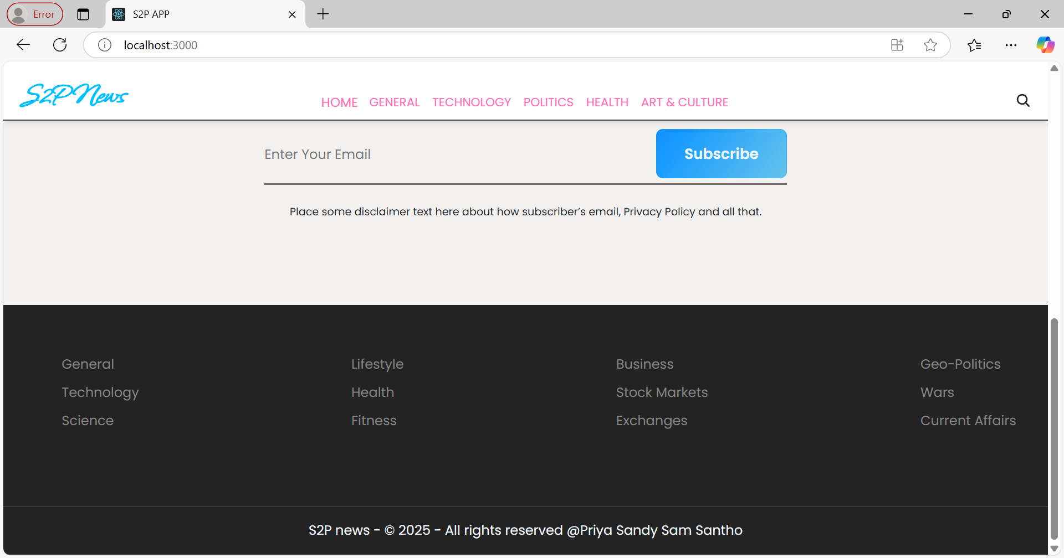

**FUTURE ENHANCEMENTS**

As the media landscape continues to evolve, the relationship between traditional and digital media becomes increasingly complex and intertwined. Both forms have unique strengths and limitations, and the future of news consumption hinges on the ability to combine their best features. Traditional media still holds significant value in maintaining credibility, delivering in-depth reports, and providing a trusted foundation for news. Meanwhile, digital media has revolutionized the way people access and engage with news, offering immediacy, personalization, and interactive elements that appeal to today’s fast-paced, digitally native audiences.

**CONCLUTION**

The hybrid model, which blends the strengths of traditional media with the flexibility of digital platforms, appears to be the most effective solution moving forward. This approach not only allows for a wider reach but also helps ensure that the news delivered is both credible and engaging. Traditional media’s commitment to editorial standards and factual reporting is vital in an age where misinformation and sensationalism are rampant, while digital platforms’ ability to deliver news quickly and directly caters to the demand for instant information.